TITLE
Abstract
Manuscripts written in both Turkish and English are accepted by the Journal of Sustainable Equity and Social Research. All submissions must be prepared in MS Office Word format (A4 size) in accordance with the journal’s official template, and Palatino Linotype must be used throughout the manuscript. The article title must be formatted in 11-point font and author names in 10-point font, both left-aligned. The main text, including the abstract, keywords, and references, must be between 4,000 and 10,000 words, written in Palatino Linotype, 10-point font, and fully justified. The English title must appear below the Turkish title in 10-point, bold italic font and left-aligned. The main text must begin on a new page with the Introduction section. All main section headings and subheadings must be written in Palatino Linotype, 10-point font, bold, uppercase, and left-aligned. A reference list arranged alphabetically and formatted in accordance with APA 7th Edition must be provided at the end of the manuscript. The abstract must summarize the purpose, scope, methodology, main findings, and conclusions of the study and containing between 150 and 250 words. Abstracts must be formatted in Palatino Linotype, 9-point font, fully justified, without paragraph indentation, and must not include references.
Keywords: Minimum 3 and maximum 7 keywords, separated by commas and written in sentence format ending with a period.

Keywords
The English translations of the keywords used in the original Turkish abstract.

1. INTRODUCTION
All text within the manuscript must be written in Palatino Linotype. The article title must be in 11 pt, and author names in 10 pt, aligned to the left. The main text, including abstract, keywords, and references, must be between 4,000 and 10,000 words, written in Palatino Linotype, 10 pt, and justified.
2. LITERATURE REVIEW
The main text must start on a new page with the Introduction section. Main section headings must be written in Palatino Linotype, 10 pt, uppercase, bold, left-aligned. Subheadings must follow the same format: uppercase, Palatino Linotype, 10 pt, bold, left-aligned.
2.1 SUBHEADING
At the end of the manuscript, a reference list arranged in alphabetical order and formatted according to APA 7 must be included. All sources cited in the text must be listed in the reference section in alphabetical order. In-text references may be indicated as “According to Botto and Rochat (2018)” or as (Botto & Rochat, 2018).
Paragraph spacing must be arranged with 0 pt before and 6 pt after, with no paragraph indentation. Footnotes are not used; in necessary cases, endnotes may be added at the end of the text in Palatino Linotype, 8 pt.
3. METHOD
If a direct quotation is less than 40 words, it must be placed within quotation marks in the running text.
If a quotation is more than 30 words, it must be presented as a block quotation in a new paragraph, indented 1.25 cm from the left margin, written in 9 pt, without quotation marks. (Dalaman vd., 2022: 8).
3. THEORETICAL FRAMEWORK
Tables must be placed in the Tables and Figures section, numbered consecutively, and referenced in the text (e.g., Table 1). Table titles must be clear and informative and must be placed above the table, written in Palatino Linotype, 9 pt, bold left-aligned, and include a source (even if created by the authors).
4. FINDINGS & DISCUSSION
Figures must be placed in the Tables and Figures section and referenced in the text (e.g., Figure 1). Figure captions must be clear and informative and include a source if applicable. For all figures, tables, or images previously published elsewhere, written permission must be obtained from the copyright holder.
5. CONCLUSION
The manuscript must be prepared in full compliance with the journal’s formatting rules.:

REFERENCES (APA 7th Edition)
Dalaman, Z. B. (2021). From secular Muslim feminisim to Islamic feminism (s) and new generation Islamic feminists in Egypt, Iran and Turkey. Border Crossing, 11(1), 77-91. https://doi.org/10.33182/bc.v11i1.1042
Akkoyun, D. B., & Dalaman, Z. B. (2024). Exploring the Intersection of Legal Regulations and Feminization of Migration: A Focus on Migrant Women Working in Domestic Services in Türkiye. Migration and Diversity, 3(1), 11-27. https://doi.org/dzhsj8
Yılmaz, V. (2020). Türkiye’de sosyal politika alanının dönüşümü ve devletin yeniden dağıtımda değişen rolü. M. Tiryakioğlu (Ed.), Devletle kalkınma içinde (15-54). İstanbul: İletişim Yayınları.
Kaya, H. (2017). Measuring pro-poor growth in Turkey. [Yüksek lisans tezi, Yıldız Teknik Üniversitesi]. Yükseköğretim Kurulu Ulusal Tez Merkezi.
Irwin, N. (2021, 29 Ocak). America’s next great economic experiment: What if we run it hot? New York Times. https://www.nytimes.com/2021/01/29/upshot/biden-economic-stimulus.html

TABLES & FIGURES (no longer than five pages, cited properly, permitted in writing by copyright owners, tables and figures must be inserted here in the order that they appear in the article)
Table 1. Sample Table
(Source: Prepared by the authors.)
Table 2.

Figure 1. Journal of Sustainable Equity and Social Research Logo
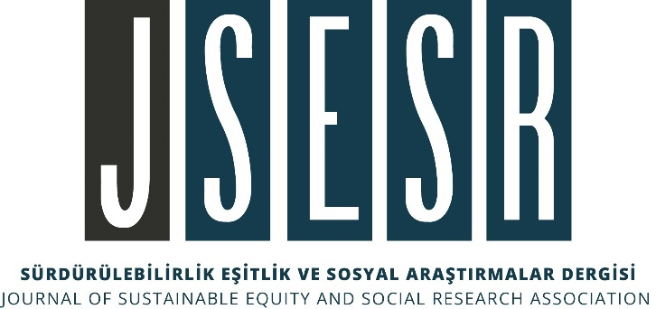
(Source: Dalaman, 2025: 34)
Figure 2.

